RAJ Publications: https://rajpublikations.yolasite.com/
Books by Randy A. John

1933 Jonegano:h (Coldspring) Census and Genealogies Published 2022
Who Is Andrew John? Published 2021

Proceedings of Remember the Removal: September 28, 2019, Allegany Territory,

Seneca Nation Published 2019
The Allegany River Serpent and Snake Stories Published 2019
A Selection of Onöndowa'ga:' (Seneca) Stories for Children Published 2019
Who Is Walter Kennedy? Published 2019
Onöndowa'ga:' Wënö:gweh (Seneca Women) Published 2019
Onöndowa'ga:' (Seneca) Treaties Published 2018
Social Integration of an Elderly Native American Population Published 2013
Onöndowa׳ge:onö’ Hadinöge:nyög Gaya:shö׳ (People of the Hills, Places and Names)
Published 2017
The Tuttle Map of Kinzua, Pa. by Randy A. John, Charles O. Tuttle Published 2017

Living with Snakes! Newspaper and Oral History Stories about Northwest Pennsylvania

during the First Half of the 20th Century Published 2020

Other Seneca History & Culture Books
Notes Of Border History— Taken on a Trip to the western part of Penna., & the
adjoining parts of N. Y. & Ohio by Jaré R. Cardinal Published 2017

Wa:dige:odë’ (They Told Stories) by Sandy Dowdy (Bilingual Seneca Stories Book)
Published 2019

Cornplanter Newsletters by Jack T. Ericson Published 2018
Seneca Indian Stories by Ha-yen-doh-nees by Leo Cooper Published 2019
Definitive Seneca: It's In The Word by Phyllis Eileen Wms. Bardeau Published 2019

COLD SPRINGS: My Home, My Memories, My Story by Stephen A. Gordon Published 2019

COLD SPRINGS A FEW STORIES by Stephen A. Gordon Published 2020
FACTIONAL DISPUTE AND PARTY CONFLICT IN THE POLITICAL SYSTEM OF THE
SENECA NATION (1845-1895): AN ETHNOHISTORICAL ANALYSIS
by Thomas S. Abler Published 2019

Carmen English Livezey’s Books about Kinzua, Pa. by Carmen English Livezey
Published 2019
SCROLL DOWN FOR BOOK DESCRIPTIONS; lulu.com ships to directly to you or your friends address
1933 Jonegano:h (Coldspring) Census and Genealogies
Transcribed by Nëhdöwes 2022 Published 2022

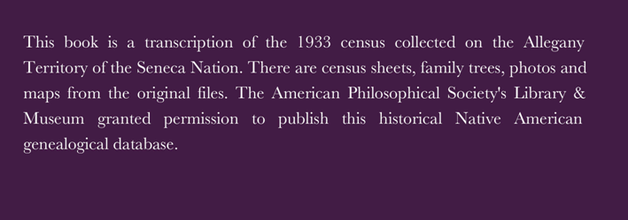
The original census has census sheets, hand-written family trees, and maps that are reproduced in the book. Some of the originals are very hard to read; they are on the left page even numbered page and the transcription is on the adjacent right, odd number page.
There are over 100 people in the census in photos, some are group photos; there is a photo list page that provides specific page numbers for each person.
There is also an index for all the people listed in the census and family trees.
Updated family trees are provided where possible with contemporary genealogical databases. The book itself is 488 pages.
This book is only available from the author, nadowes@yahoo.com

Who Is Andrew John?
Published 2021
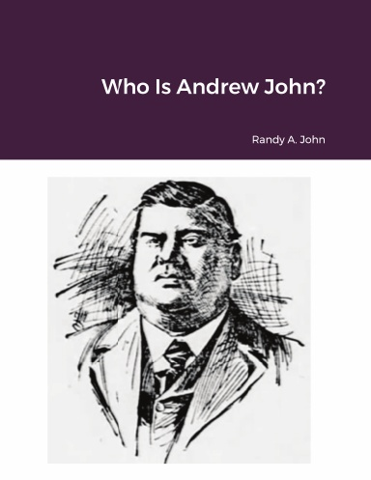
This book details the political lives of two Cattaraugus Territory Seneca Leaders, father and son; Andrew John Senior and Junior. Chapter one summarizes major political issues every Seneca politician and member faced in the 19th century and into the 20th century. They are treaties and rights of preemption, Seneca Nation political revolution, emergence of private property, leasing, severalty (allotment) legislation/Indian removal policy, and federal citizenship legislation. Chapters two and three provides a historical and political biography of the father and son. In addition, the appendices provide a genealogy of Andrew John Sr. and Jr., a chronology of recorded events that involved them, and a Seneca Nation leasing chronology. It is important to note the limitations of this book as a myopic political analysis that does not include the social patterns of Seneca life and the good white neighbors the Senecas lived near, interacted with in everyday life, and sometimes intermarried with, and the good folks who helped Senecas in need, including missionaries.

Lulu.com search terms “Who Is Andrew John”

Proceedings of Remember the Removal: September 28, 2019 Allegany Territory Seneca Nation

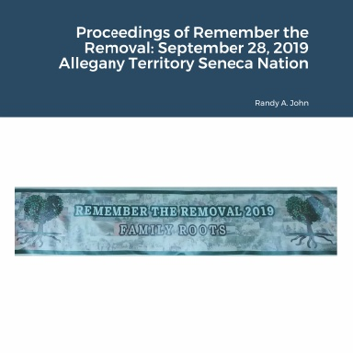

In the 1960s, the Seneca Nation lost control of 10,000 acres of treaty protected land. The 1794 Pickering Treaty protects Iroquois land, yet, the United States allowed the violation of this treaty for flood control. At the time hydro energy was never mentioned but became a multimillion profitable enterprise for federal contractors, without profit sharing with the land owners, the Senecas. Since the 1980s, the Seneca people and friends have commemorated this sovereign infringement. This book provided historical newspaper articles and a large collection of pictures of the 2019 "Remember The Removal." It also provides speeches and comments about the travesty the Kinzua Dam caused for Indian and Pennsylvania non-Indians after their homelands were flooded permanently.

Lulu.com search terms “Proceedings of Remember the Removal: September 28, 2019 Allegany Territory Seneca Nation”

The Allegany River Serpent and Snake Stories

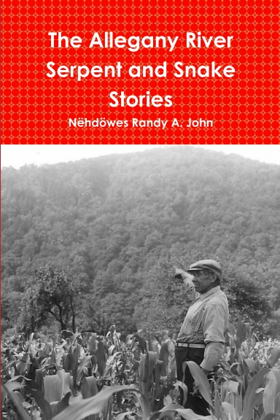

This book provides contemporary oral histories of the serpent that inhabits the Allegany River at the Allegany Territory of the Seneca Nation. There is a complete collection of 20 traditional Seneca serpent and snake stories. People of all ages and cultures will be interested in reading elements of this book. Two Seneca artists have provided original serpent drawing for this book.

Lulu.com search terms “Allegany River Serpent”

A Selection of Onöndowa'ga:' (Seneca) Stories

for Children
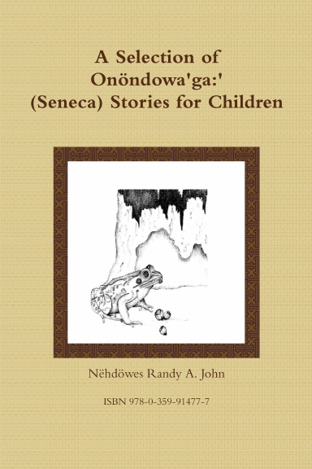

Seneca Elders told these stories for centuries. In the 19th century, American researchers heard these stories in the Seneca language and the bilingual storyteller interpreted these moralistic tales into English. These writers published the cultural tales elders told to their youth during the winter months. Adults will enjoy this book and it is perfect for children of all cultures.

Lulu.com search terms “seneca stories for children”

Who Is Walter Kennedy?

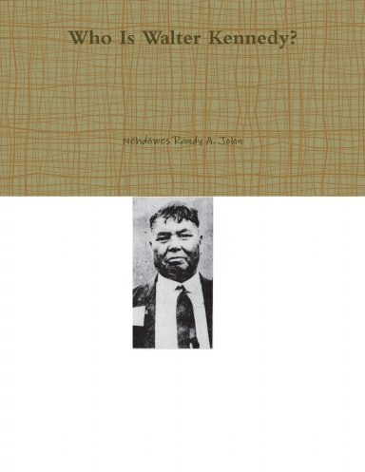
This book is a genealogical research project on two Seneca Nation members in the late 19th and early 20th centuries, Walter "Boots" Kennedy and Walter Scott Kennedy. Both were political leaders in their communities and are known via political events in the early 20th century. Family pedigrees and family group sheets are provided with a brief biography of both men and their accomplishments.

Lulu.com search terms “Walter Kennedy”

Onöndowa'ga:' Wënö:gweh (Seneca Women)

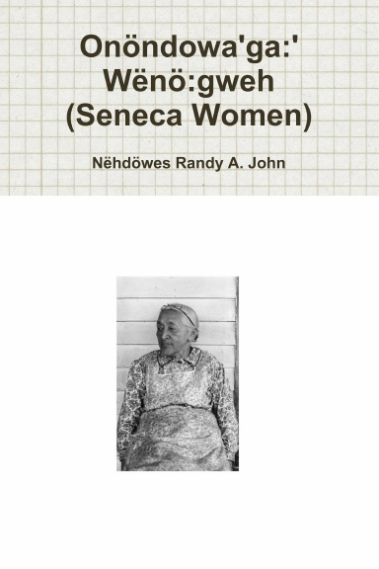
The Hodinöhsö:ni' are a matriarchal society, women are a powerful entity. Membership is matrilineal, traditionally, the clan mother position holds a tremendous amount of responsibility to society. This book is a collection of Seneca women’s names with a brief description for each entry. There are 252 names ranging from the 1600's to the 21st century. All the female Clerks of the Seneca Nation of Indians are listed. For the Senecas, the 1848 political revolution creating an elective system of political government; reduced the power of women for over a century. In the late 1960s, women regained political power and began to vote and run for office in the Seneca Nation of Indians. Since 1968, a woman has won the executive position of Clerk every election since.
Lulu.com search terms “Seneca Women”

Onöndowa'ga:' (Seneca) Treaties
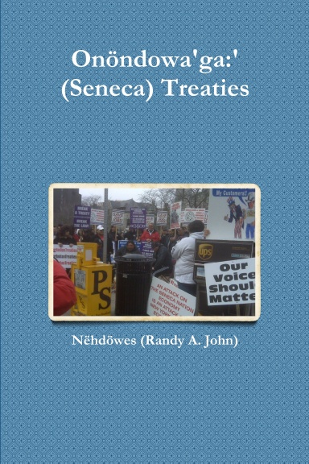

This reference book compiles all of the treaties of the Seneca people with the United States from 1784 to 1867. It is divided into two sections, treaties held with Senecas residing in what is now New York and Ohio. Current and future generations of Senecas and Americans should be aware of these treaties and their significance. The 1794 treaty remains in effect today in perpetuity. Genealogists will appreciate the plethora of Seneca signatures on these documents. Every library should have a copy of this book.
Lulu.com search terms “Seneca treaties”

Social Integration of an Elderly Native American Population
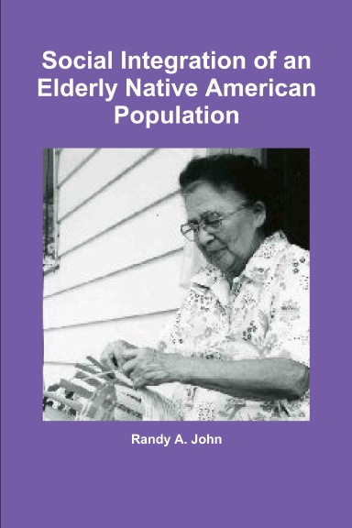
The building of the Kinzua Dam abrogated one of the oldest Indian Treaty with the United States, the 1794 Pickering Treaty. The dam flooded 10,000 acres of Seneca land and damaged the way of life of the Senecas and their elders. The stories of their loss are distressing. The Senecas survived this traumatic event but not without significant cultural change and loss. This is the story of the dislocated Seneca Elders of the Allegany Territory.
Lulu.com search terms “social integration of an elderly”

Onöndowa׳ge:onö’ Hadinöge:nyög Gaya:shö׳ (People of the Hills, Places and Names)
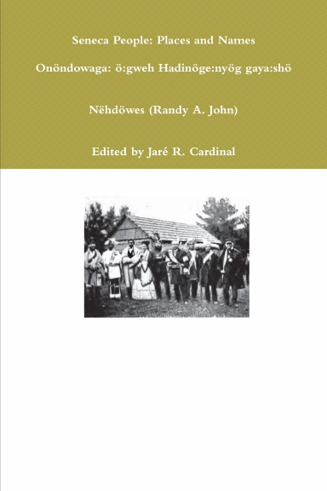
This book is an extensive literature survey of Seneca names and places. There are over 2,300 names and 370 Onöndowa'ga:' place names ranging from the 1600's to the 21st century. All the Presidents of the Seneca Nation of Indians are listed along with traditional leaders identified in historical literature. A list of Seneca students at the Thomas Indian School, Tunesassa Quaker School, and several years of the Cornplanter Grant School are included. Clan names and a Seneca veterans list including the Civil War, The War of 1812, and World War Two are provided as well. A brief list of Seneca adoptees is included in the appendices. There is no other publication available with these contents.

Lulu.com search terms “people of the hills”
The Tuttle Map of Kinzua, Pennsylvania
by Randy A. John and Charles O. Tuttle
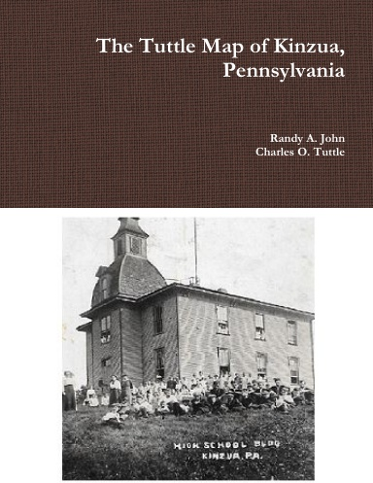
In the late 1900s to early 2000s, Charles O. Tuttle recreated a map of the Houses and their owners at Kinzua, Pennsylvania in the 1930s. The settlement no longer exists, the Kinzua Dam flooded the town in the 1960s. The former residents have an annual reunion every July. The original handwritten map is reproduced into visible sections. Charle's son Denny possesses the Tuttle map of Kinzua, Pennsylvania. This non-Indian community is often overlooked by the national attention the Senecas received in the 1960s.
Lulu.com search terms “tuttle map”

Living with Snakes! Newspaper and Oral History Stories about Northwest Pennsylvania during the First Half of the 20th Century by Randy A. John
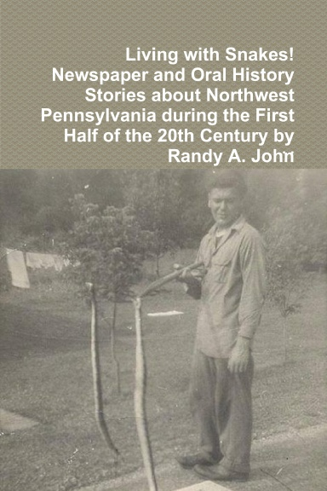
This book was inspired by the former residents of Corydon, Elko, Kinzua, Morrison, Onoville, Quaker Bridge, and Wolf Run who shared stories about their way of life with me before the Kinzua Dam displaced their communities in the mid-1960s. The oral histories are summarized along with newspaper accounts of encounters with rattlesnakes from 1900 to 1971. One of these articles details a rattlesnake recipe used back in the day. It ends with contemporary rattlesnake information, State regulations and safety recommendations.
Lulu.com search terms “living with snakes”

Notes Of Border History— Taken on a Trip to the western part of Penna., & the adjoining parts of N. Y. & Ohio by Jaré R. Cardinal
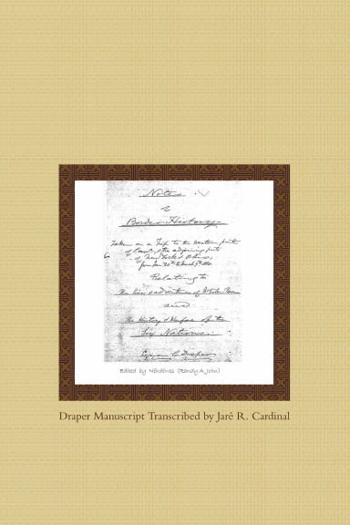
This is a transcription of the Draper manuscript, Series 4 S. This provides a unique native view based on interviews with Seneca Indians and a manuscript of the significant Seneca leader, Governor Blacksnake. This is the Seneca oral history of the American Revolution. Non-Indians are included in Draper's interviews in western Pennsylvania, New York & Ohio. This is a cultural find for historians and genealogists.
Lulu.com search terms “Notes Of Border History”

Wa:dige:odë’ (They Told Stories) by Sandy Dowdy
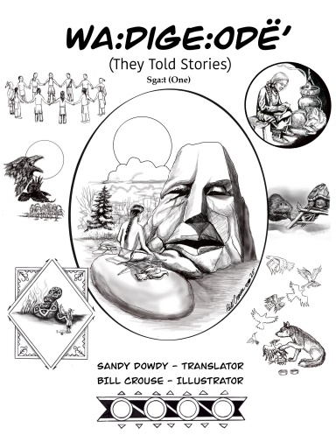
This bilingual book converts Seneca stories back into the original Seneca language, as they were told to researchers on Seneca Territories almost a century ago. The author is a fluent first language Seneca speaker. These stories will become part of the daily curriculum of the Seneca Faithkeepers School. This book reflects the resilient effort of the Seneca people to maintain their original language in the 21st century. All profits are donated to the school at Coldspring on the Allegany Territory of the Seneca Nation. Seneca Artist, Bill Crouse, provides original drawings for the front cover and each story.
Lulu.com search terms “Sandy Dowdy”

Cornplanter Newsletters by Jack T. Ericson
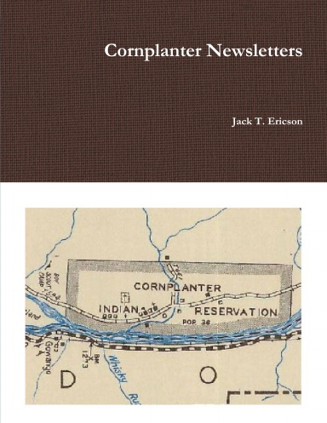
This book is a reprint of the Cornplanter Descendants Association Newsletters originally published 1994 to 2005. Jack T. Ericson is the genealogists and editor of the series. The book includes a new name index not previously available. This collection is a priceless for Cornplanter descendants of the Seneca Nation of Indians. The land given to Cornplanter by the Commonwealth of Pennsylvania in the 1790s was flooded by the Kinzua Dam built in 1965.
Lulu.com search terms “Cornplanter Newsletters”

Seneca Indian Stories by Ha-yen-doh-nees Leo Cooper
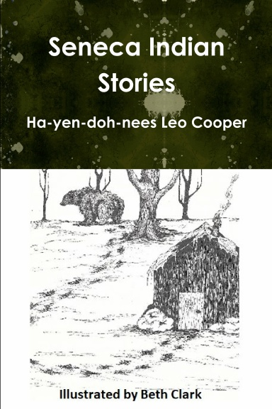
This reprint of Leo Cooper's children stories is a wonderful collection. The Seneca elders shared these cultural stories with Leo that are preserved in this book. This collection is appropriate for all children of all cultures. In traditional times, the Senecas told these stories in the winter. Stories are not simply for entertainment, they also provided moral development of the younger generation. This book should be in all libraries and classrooms!
Lulu.com search terms “Leo Cooper”

Definitive Seneca: It's In The Word

by Phyllis Eileen Wms. Bardeau
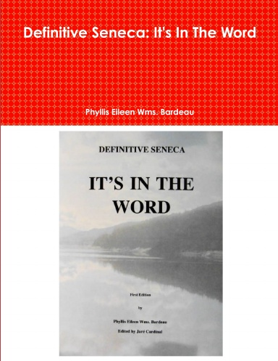
Gayanögwad’s (Phyllis Eileen Wms. Bardeau, Deer Clan) English-Onöndowa'ga:' (Seneca) dictionary is a cultural and linguistic treasure trove. Eileen, a fluent first language speaker and elder, speaks and records the Onöndowa'ga:' language as she learned it from her grandmother, several generations ago before the building of the Kinzua Dam in the 1960s. This tragic treaty violation accelerated language loss by breaking up almost two century old communities at Ohi:yonö’ (Allegany Territory residents, Lit. people of the Ohi:yo׳) of the Onöndowa'ga:'. She devotes her life to the preservation of the Onöndowa'ga:' language. Phyllis created Definitive Seneca: It’s In The Word is a permanent tool to study culture through language. Gayanögwad has taught the language in the community, for the Seneca Nation, and at the University level. This publication should be in every library for students of the Onöndowa’ga:’ Gawë:nö׳ (Language of the People of the Great Hills).
Lulu.com search terms “Phyllis Eileen Wms.”

COLD SPRINGS: My Home, My Memories, My Story
by Stephen A. Gordon
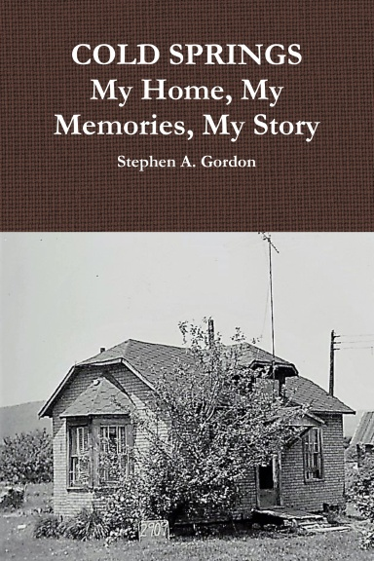

This book is a first-hand account of Stephen A. Gordon and his family's dislocation from their homestead on the Allegany Territory of the Seneca Nation violated the 1794 Treaty between the United States and the Hodinöhsö:ni' (Iroquois) which the Onöndowa'ga:' (Seneca) are original members.

Lulu.com search terms “Stephen A. Gordon”

COLD SPRINGS A FEW STORIES by Stephen A. Gordon
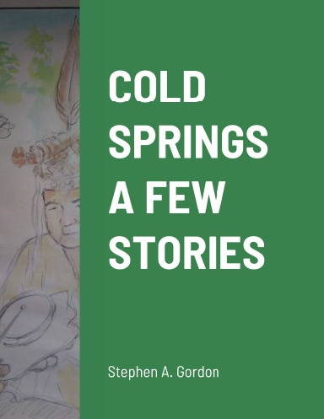
Cold Springs is a Native American community located on the Seneca Nation of Indians Territory. The land is described and secure within the boundaries of the Canandaigua Treaty of 1794. Its name comes from the underground springs that dot along the Allegany River. The Native people who inhabited this area came from Cornplanter, Buffalo Creek, Six Nations Territory, Ganondagan. They were blessed with fertile soil, abundant game in the forest and the purest water. A human being could live a lifetime living off the land. No written history exists of when it was first populated. Land and generations of people lived in harmony. This was all disrupted in 1964 with the construction of the Kinzua Dam which inundated 10,000 acres of Seneca land and displaced 140 families. Everything below the 1,365 elevation was considered in the take-area. Cold Springs went under water only once, in 1971, and remains abandoned and landlocked. This land is where the author, Stephen A. Gordon lived from 1951 to 1964. Like the cold springs that seep out of the earth along the Allegany River, these stories have surfaced and are presented to the future generations.
Lulu.com search terms “Stephen A. Gordon”

FACTIONAL DISPUTE AND PARTY CONFLICT IN THE POLITICAL SYSTEM OF THE SENECA NATION (1845-1895): AN ETHNOHISTORICAL ANALYSIS

by Thomas S. Abler
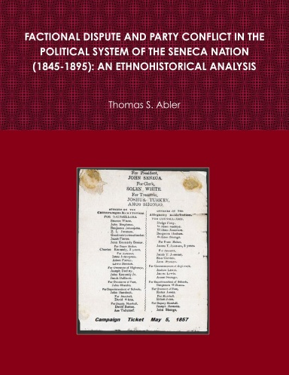
Abler's dissertation on Seneca Nation politics provides an insight into one of the most tumultuous eras of Onöndowa'ga:' history, when an elective system was established, replacing its Council of Chiefs. Unsavory actions of land speculators in collusion with federal and state officials had led to the loss of over 6 million acres of Seneca territory by 1842. This upheaval was also prompted in part by how treaty annuities were distributed and by the meddling of Hicksite Quakers who urged reform. In 1848, the new government marked the abandonment of the traditional governmental practices that had been in existence for centuries. The aftermath of the revolution resulted in a decades-long struggle between the proponents of the old chieftain system and the new elective system. The new government had to contend with railroad, timber, and oil companies intent on promoting leasing and/or allotment, the latter aimed to facilitate the transfer of ownership away from the Senecas.
Lulu.com search terms “Thomas S. Abler”

Carmen English Livezey’s Books about Kinzua, Pennsylvania
By Carmen English Livezey
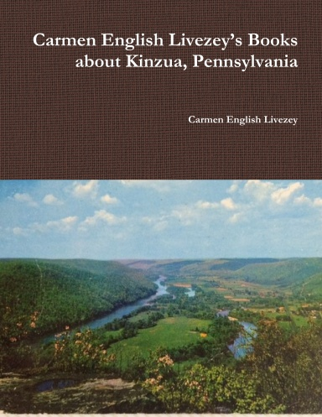
Carmen English Livezey wrote four books on the town of Kinzua, Pa. after the building of the Kinzua Dam in the 1960s. Her works emphasized the strong sense of community among the residents. The lives of the people are described in a fashion of personal detail. This is not an academic study, rather it is a celebration of a personal and wonderful rural way of life in a beautiful setting. The reprint was commissioned for the 2018 Kinzua Reunion for the former residents and descendants of that wonderful place, Kinzua, Pennsylvania.
Lulu.com search terms “Carmen English Livezey”

